Exercise Java 9-17

1. Demonstrate the use of private methods in interfaces

Answer:

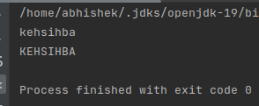

1. Perform takeWhile and dropWhile operations on stream

Answer:

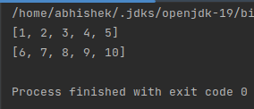

1. Use rangeClosed to create a Stream

Answer:

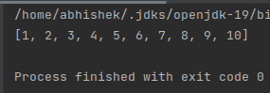

1. Use iterator stream method to generate a stream

Answer:

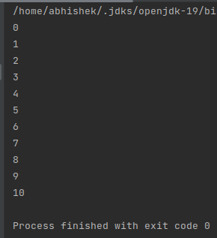

1. Use ifPresentOrElse, or, orElseThrow Operations with Optional

Answer:

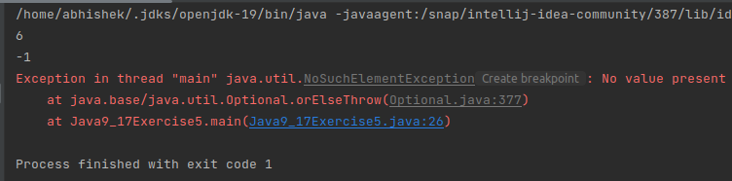

1. Convert an Optional type into Stream

Answer:

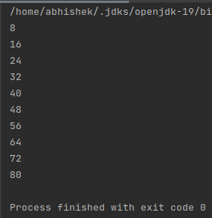

1. Use Of method to create List, Set and Map

Answer:

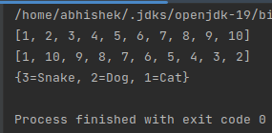

1. Demonstrate the use AutoCloseable

Answer:

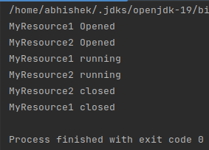

1. Create Unmodifiable List from a Steam

Answer:

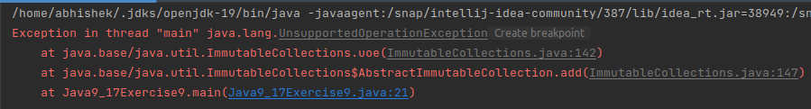

1. Demonstrate the use of repeat, strip, isBlank, indent, transform, stripIndent, translateEscapes, formatted String methods.

Answer:

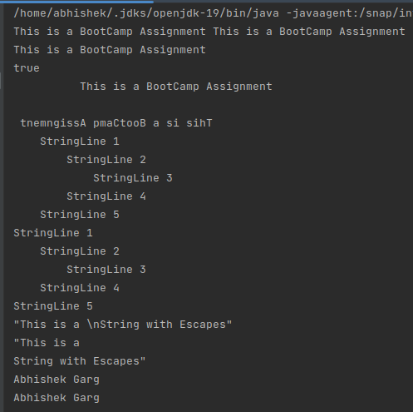

1. use record to create an immutable represent of student(name, id, age) and use its constructor for initialization, equals to compare 2 students methods. Also keep a static counter to keep the count of objects created.

Answer:

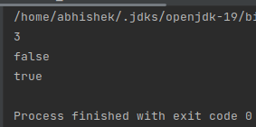

1. Demonstrate the use of Sealed Classes.

Answer:

